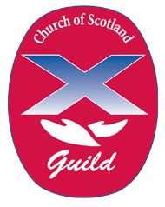
LARGS UNITED GUILD
February to March 2022
A warm welcome awaits everyone
at 2.00pm on Monday afternoons in the Dunn Memorial Hall
when you can enjoy some interesting topics,
fellowship with friends, old and new, and a cup of tea.
The programme for the next few weeks is as follows: -
Feb 7 The Ayrshire Harbours John Riddell
Feb 14 Walking the Camino Way Owen Quinn
Joint Meeting
Feb 21 CHAS Speaker to be arranged
Feb 28 Elsie Inglis and the Scottish
Women’s Hospitals WW1 Barbara Graham
Mar 7 Kazunzu, Village of Hope Very Rev Albert Bogle
Project
Mar 14 How our Ancestors Kept in Touch June Wiggins
Mar 21 Music with Sonoro Rhona Gourley
Mar 28 ABM Rally DVD

Please feel free to come along to any or all of these meetings

